
June 2019

The Windsor Wire
Windsor House Greenville * 1931 Pelham Rd., Greenville ,SC 29615 * (864) 288-9450
Celebrating June  Staff  Renee Wilson  Administrator  Tanoa Taylor  Administrative Assistant  Angela Oller  Activity Director  John Fullmer  Executive Chef  Reggie Harvey  Maintenance  Birthdays  Shelia Wright  6/8  Edith Doolittle  6/13  Norman Chandler  6/23  Tanoa Taylor  6/6  Sandy Lee  6/8 | Father’s Day Celebration  We will be honoring the gentlemen of Windsor House with refreshments and a few fun dad games.    June 14, 2019 at 3:00pm  Family members whom would like to attend please R.S.V.P.  Angela Oller  Text, Call, or Email to  864-436-6016  aoller@windsorhousegreenville.com  ___________________________________________  We are working on a cook book to benefit the Alzheimer’s Association and would like to put our residents and their families’ favorite recipes in the Cook Book. If you have a recipe you can share please email it to Angela at the above email address or bring it by Windsor House.    N

  June 2019  New Books for the Library!    We have received several large donations of books of all kinds. This month thanks to our community. We are looking to get a few more children’s books.  We are making a children’s corner in the library for our residents who want to have a sweet moment with their precious grandbabies.  Please feel free to bring a favorite book to share with others. You can bring it to Angela Oller (Activity Director), she will make sure the book is placed on the shelf. | Three Indigent Peanut Butter Cookies  1 cup Peanut Butter  1 cup Sugar  1 egg  - Preheat oven to 350°. Line a baking sheet with parchment paper.  - Mix all ingredients until smooth  - Drop spoonfuls on lined baking sheet.  - Bake for 6 to 8 minutes until light golden brown on bottom of cookie. Don’t over bake.  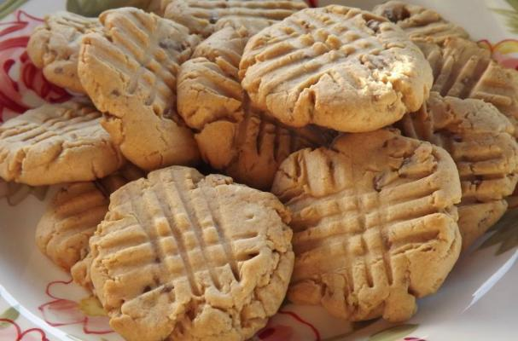
 | Postage Information
A Bunch of Hot Air    Hot Air Balloon Day, on June 5, celebrates the incredible achievement of the Montgolfier brothers. On this day in 1783,  the brothers demonstrated the  first unmanned flight of a hot  air balloon in the skies above their hometown  of Annonay, France. The balloon itself was constructed of taffeta, fabric, and paper. It  may seem amazing that it lifted off the ground  at all considering that it weighed in at over 500 pounds. But fly it did, reaching a tremendous height of 6,000 feet. The Montgolfier brothers knew their invention was a wonder, and they decided to take it to Paris for a demonstration  in front of King Louis XVI and Marie Antoinette. The balloon was still unmanned, but no less marvelous for its historic flying of a rooster, duck, and sheep before a crowd of 130,000 Parisians. The miracle of flight had, at last, moved from imagination to reality. | June Birthdays  In astrology, those born June 1–20 are  Gemini’s Twins. Twins seem to have two personalities and can blend into any situation. They have an energetic and fun-loving side  that is the life of the party, but also a deep and emotional side that needs love and nurturing. Those born June 21–30 are the Crabs of Cancer. Guided by their hearts, Crabs are emotional and nurturing. They create deep bonds and comfortable homes and are always willing to welcome people into their circle.  Marilyn Monroe (actress) – June 1, 1926  Josephine Baker (entertainer) – June 3, 1906  Tom Jones (singer) – June 7, 1940  Frank Lloyd Wright (architect) – June 8, 1867  Harriet Beecher Stowe (author) – June 14, 1811  Igor Stravinsky (composer) – June 17, 1882  Lionel Ritchie (singer) – June 20, 1950  Octavia Butler (writer) – June 22, 1947  Pearl S. Buck (writer) – June 26, 1892  John Elway (quarterback) – June 28, 1960
Windsor House Greenville
1931Pelham Rd
Greenville, SC 29615

